Product Risk Analysis and Project Risk Analysis

1-Product Risk Analysis

🔹 Definition
# Source: AI Source: Provided by: [Data Path: Persons Table -> ID Column: 1, Name_En Column: Motasem Essam] -> From: [Chatgpt (GPT‑5 Mini)] on [8/24/2025]
Product Risk Analysis is the process of identifying and evaluating risks related to the quality and functionality of the product being developed or tested.
It answers the question:
👉 “What could go wrong in the product that might cause failure, defects, or dissatisfaction for users or stakeholders?”

🛠️ Steps in Product Risk Analysis

1. Identify Product Risks
# Source: AI Source: Provided by: [Data Path: Persons Table -> ID Column: 1, Name_En Column: Motasem Essam] -> From: [Chatgpt (GPT‑5 Mini)] on [8/24/2025]
- Gather risks related to product features, design, performance, security, and usability.
- Example: “Payment gateway may fail under high load.”

2. Categorize Risks
# Source: AI Source: Provided by: [Data Path: Persons Table -> ID Column: 1, Name_En Column: Motasem Essam] -> From: [Chatgpt (GPT‑5 Mini)] on [8/24/2025]
Common categories of product risks:
- Functional Risks – features not working as expected (e.g., login fails).
- Non-functional Risks – performance, security, usability, compatibility.
- Compliance Risks – product not meeting legal/regulatory requirements.
- Data Risks – data loss, corruption, privacy breaches.
- User Experience Risks – confusing UI, accessibility issues.

3. Assess Likelihood & Impact
# Source: AI Source: Provided by: [Data Path: Persons Table -> ID Column: 1, Name_En Column: Motasem Essam] -> From: [Chatgpt (GPT‑5 Mini)] on [8/24/2025]
- Estimate how likely the risk is to occur.
- Estimate how severe the consequences will be if it occurs.
📊 Example:
- Risk: “Mobile app crashes on iOS 17 devices.”
  - Likelihood: Medium
  - Impact: High (blocks major user group)
  - Priority: High

4. Prioritize Risks
# Source: AI Source: Provided by: [Data Path: Persons Table -> ID Column: 1, Name_En Column: Motasem Essam] -> From: [Chatgpt (GPT‑5 Mini)] on [8/24/2025]
- Combine Likelihood × Impact to calculate a Risk Score.
- Helps testers and developers focus on the most critical areas.

5. Plan Risk-Based Testing
# Source: AI Source: Provided by: [Data Path: Persons Table -> ID Column: 1, Name_En Column: Motasem Essam] -> From: [Chatgpt (GPT‑5 Mini)] on [8/24/2025]
- Testing effort is aligned with high-risk product areas.
- Example: Spend more test time on “online payment processing” than on “user profile picture upload.”

6. Document in a Product Risk Register
# Source: AI Source: Provided by: [Data Path: Persons Table -> ID Column: 1, Name_En Column: Motasem Essam] -> From: [Chatgpt (GPT‑5 Mini)] on [8/24/2025]
- Maintain details: risk description, priority, owner, mitigation/testing strategy.
📑 Example:
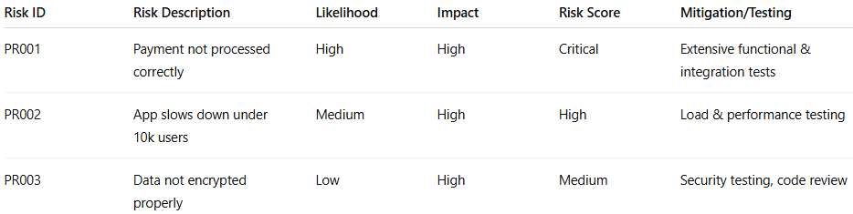
Risk ID | Risk Description | Likelihood | Impact | Risk Score | Mitigation/Testing
PR001 | Payment not processed correctly | High | High | Critical | Extensive functional & integration tests
PR002 | App slows down under 10k users | Medium | High | High | Load & performance testing
PR003 | Data not encrypted properly | Low | High | Medium | Security testing, code review

🔹 Example in Real Life
# Source: AI Source: Provided by: [Data Path: Persons Table -> ID Column: 1, Name_En Column: Motasem Essam] -> From: [Chatgpt (GPT‑5 Mini)] on [8/24/2025]
Imagine an e-commerce app:
- Product Risks:
  - Checkout flow might fail with certain credit cards.
  - Discounts might be applied incorrectly.
  - Mobile version might not display product images correctly.
👉 These risks drive test design → meaning testers focus more on checkout, payments, and mobile UI than on low-risk areas like “change profile picture.”

✅ In short:
Product Risk Analysis = analyzing risks that could affect the product’s quality, features, performance, and user satisfaction → then focusing testing effort on those high-risk areas.

2-Project Risk Analysis

🔹 Definition
# Source: AI Source: Provided by: [Data Path: Persons Table -> ID Column: 1, Name_En Column: Motasem Essam] -> From: [Chatgpt (GPT‑5 Mini)] on [8/24/2025]
Project Risk Analysis is the process of examining identified project risks to determine:
- their likelihood (probability) of happening,
- their impact on project objectives (scope, schedule, cost, quality),
- and their priority for management.
It helps the project team decide which risks need immediate action and which can be monitored.

🛠️ Steps in Project Risk Analysis

1. Risk Identification
# Source: AI Source: Provided by: [Data Path: Persons Table -> ID Column: 1, Name_En Column: Motasem Essam] -> From: [Chatgpt (GPT‑5 Mini)] on [8/24/2025]
- Collect possible project risks (e.g., resource shortage, schedule delays).
- Sources: brainstorming, past projects, expert judgment, checklists.
- Example: “Critical developer may leave during the project.”

2. Risk Categorization
# Source: AI Source: Provided by: [Data Path: Persons Table -> ID Column: 1, Name_En Column: Motasem Essam] -> From: [Chatgpt (GPT‑5 Mini)] on [8/24/2025]
- Group risks into categories for clarity.
- Examples:
  - Schedule Risks (delays, missed milestones)
  - Budget Risks (cost overruns)
  - Resource Risks (lack of skills, unavailability)
  - Scope Risks (requirements creep)
  - External Risks (vendor delays, regulatory changes)

3. Risk Assessment (Qualitative & Quantitative)
# Source: AI Source: Provided by: [Data Path: Persons Table -> ID Column: 1, Name_En Column: Motasem Essam] -> From: [Chatgpt (GPT‑5 Mini)] on [8/24/2025]
- Qualitative Analysis (most common in IT projects):
  - Rank risks based on likelihood (Low/Medium/High) and impact (Low/Medium/High).
  - Use a Risk Matrix to prioritize.
- Quantitative Analysis (for large, critical projects):
  - Assign numerical values (e.g., 30% probability × $50,000 cost impact = $15,000 risk exposure).
  - Use simulations, decision trees, or sensitivity analysis.

4. Risk Prioritization
# Source: AI Source: Provided by: [Data Path: Persons Table -> ID Column: 1, Name_En Column: Motasem Essam] -> From: [Chatgpt (GPT‑5 Mini)] on [8/24/2025]
- Combine Likelihood × Impact to get a Risk Score.
- High-score risks need mitigation plans; low-score risks can be monitored.
📊 Example Risk Matrix:
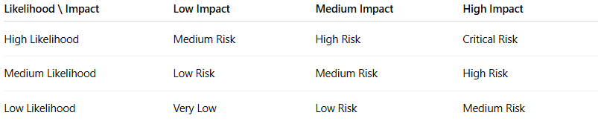
Likelihood \ Impact | Low Impact | Medium Impact | High Impact
High Likelihood | Medium Risk | High Risk | Critical Risk
Medium Likelihood | Low Risk | Medium Risk | High Risk
Low Likelihood | Very Low | Low Risk | Medium Risk

5. Risk Response Planning
# Source: AI Source: Provided by: [Data Path: Persons Table -> ID Column: 1, Name_En Column: Motasem Essam] -> From: [Chatgpt (GPT‑5 Mini)] on [8/24/2025]
- For each high-priority risk, plan actions:
  - Avoid (change plan to eliminate risk)
  - Mitigate (reduce probability/impact)
  - Transfer (outsource, insurance, SLA with vendor)
  - Accept (do nothing, monitor, prepare contingency plan)

6. Risk Documentation & Monitoring
# Source: AI Source: Provided by: [Data Path: Persons Table -> ID Column: 1, Name_En Column: Motasem Essam] -> From: [Chatgpt (GPT‑5 Mini)] on [8/24/2025]
- Document in the Risk Register (risk ID, description, category, likelihood, impact, owner, mitigation).
- Monitor continuously and update as project progresses.

🔹 Example – Project Risk Analysis
# Source: AI Source: Provided by: [Data Path: Persons Table -> ID Column: 1, Name_En Column: Motasem Essam] -> From: [Chatgpt (GPT‑5 Mini)] on [8/24/2025]
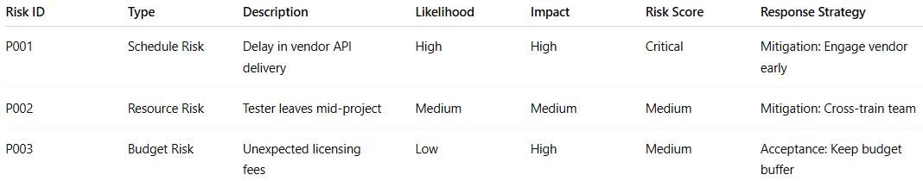
Risk ID | Type | Description | Likelihood | Impact | Risk Score | Response Strategy
P001 | Schedule Risk | Delay in vendor API delivery | High | High | Critical | Mitigation: Engage vendor early
P002 | Resource Risk | Tester leaves mid-project | Medium | Medium | Medium | Mitigation: Cross-train team
P003 | Budget Risk | Unexpected licensing fees | Low | High | Medium | Acceptance: Keep budget buffer

✅ In short:
Project Risk Analysis = evaluating project-related risks (time, cost, scope, resources) to prioritize and plan responses so the project is delivered successfully.

